ИИН 851002402558
Тел:87753235349
КАШКИНБАЕВА Акерке Ауелхановна,
№31 Ш.Уәлиханов атындағы жалпы білім беретін мектебінің ағылшын тілі пәні мұғалімі.
Түркістан облысы, Келес ауданы

HEALTHY FOOD
Learning objectives(s) that this lesson is contributing to: | 6.6.1.1 begin to use basic abstract nouns and compound nouns and noun phrases describing times and location on a growing range of familiar general and curricular topics  6.2.5.1 understand most specific information and detail of short, supported talk on a wide range of general and curricular topics
Lesson objectives: | Learners will be able to:  Know vocabulary from previous lesson  Translate the text correctly, speak about previous lesson grammar  Work in group, think creative, answer to all questions about health and germs
Value link: | Be friendly, respect each other.
Plan:
Part of the lesson/Time | Teacher’s activity | Student’s activity | Assessment | Resources
Beginning of the lesson  Warming-up  Team work  5 min. | Organization moment:  1.Greeting.  Ask about the weather.  The teacher sets the lesson objectives, letting students know what to anticipate from the lesson.  Warm-up  students divided into two groups with method Lemon Tea | Increasing students` psychological motivation.  “Emojis” method helps to start the lesson with good feelings  The aim: To develop pupils speaking skills and create friendly atmosphere  Efficiency: By wishing each other they feel better and feel the support of others | At the organization moment T tries to award active Ss. «The praise» method is used to evaluate Ss with phrases like:  “Good job!  Well done!” | CD player  Sun  Clouds  Cards  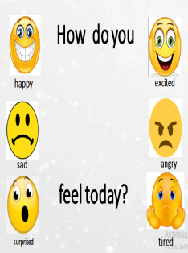  Pictures of Tea
Pair work  6 min. | - Read and translate | Ss read the mystery words  Aim: Revise the previous lessons material. Find out how much do they remember. | Descriptor:  -read correctly  -  Total: 1point | Whiteboard  Cards  Student’s book  Spiral text
Middle of the lesson  Presentation part.  7 min. | - Look, read and choose  In differentiation part «Wordwall » method was used to check up student’s vocabulary knowledge. | Ss read the mystery words  Aim: Revise the previous lessons material. Find out how much do they remember. | Descriptor:  -can read  Total: 1point | Whiteboard  Student’s book Flashcards  https://wordwall.net/resource/5178409
Individual work  7 min  Writing task  Wordwall platform  7 min  Physical training  3 min  Individual work  5 min | Ex 1. Which of the following sentences are true or false ?  Halloween sweets method is used in this task  Look, read and choose  Ex 2. use the words below and must/mustn’t to write complete sentences.  Physical training  Group work  Translate the words correctly and create full triangle  Look, read and choose | Ss do exercise 4 a and b.  Work as a pair, think then complete the table.  Ask and answer the questions  Students choose correct word  Learners must complete  Learners must create full shape  Learners must choose and say correct answers | Descriptor:  -know new words-1point.  -can ask and answer the questions 1 point  -can use new grammar material -1point.  can ask and answer the questions 1 point  can find correct word formations  1 point | Whiteboard  Student’s book    Method: wordwall https://wordwall.net/resource/6504608    Dodokaedr method  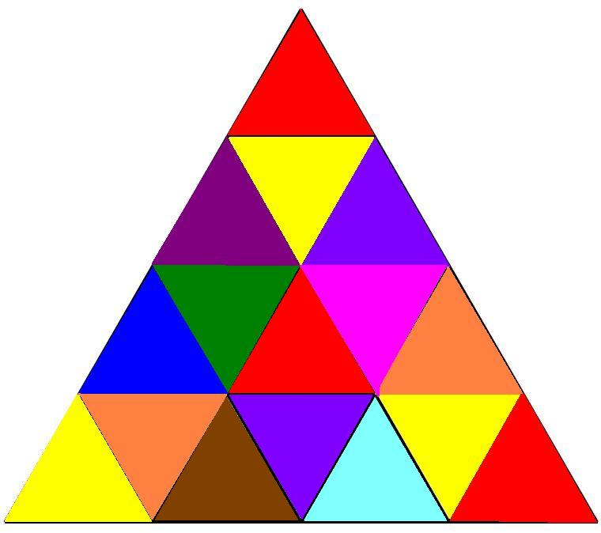  https://wordwall.net/ru/resource/9361688
End of the lesson.  Reflection  Individual work:  5 min. | The Education tree method was used as a reflection. T asks Ss to stick their stickers to the Education tree | Ss use their stickers to show their knowledge according to the lesson  Green - I understood  Yellow -I have some questions  Red -I need a help.  Aim: To know how many Ss got the theme. | Descriptor:  Ss evaluate each other and encourage classmate with phrases like:  Well done! Brilliant! Good job! I like it! | Whiteboard  Student’s book Poster  Education doors

